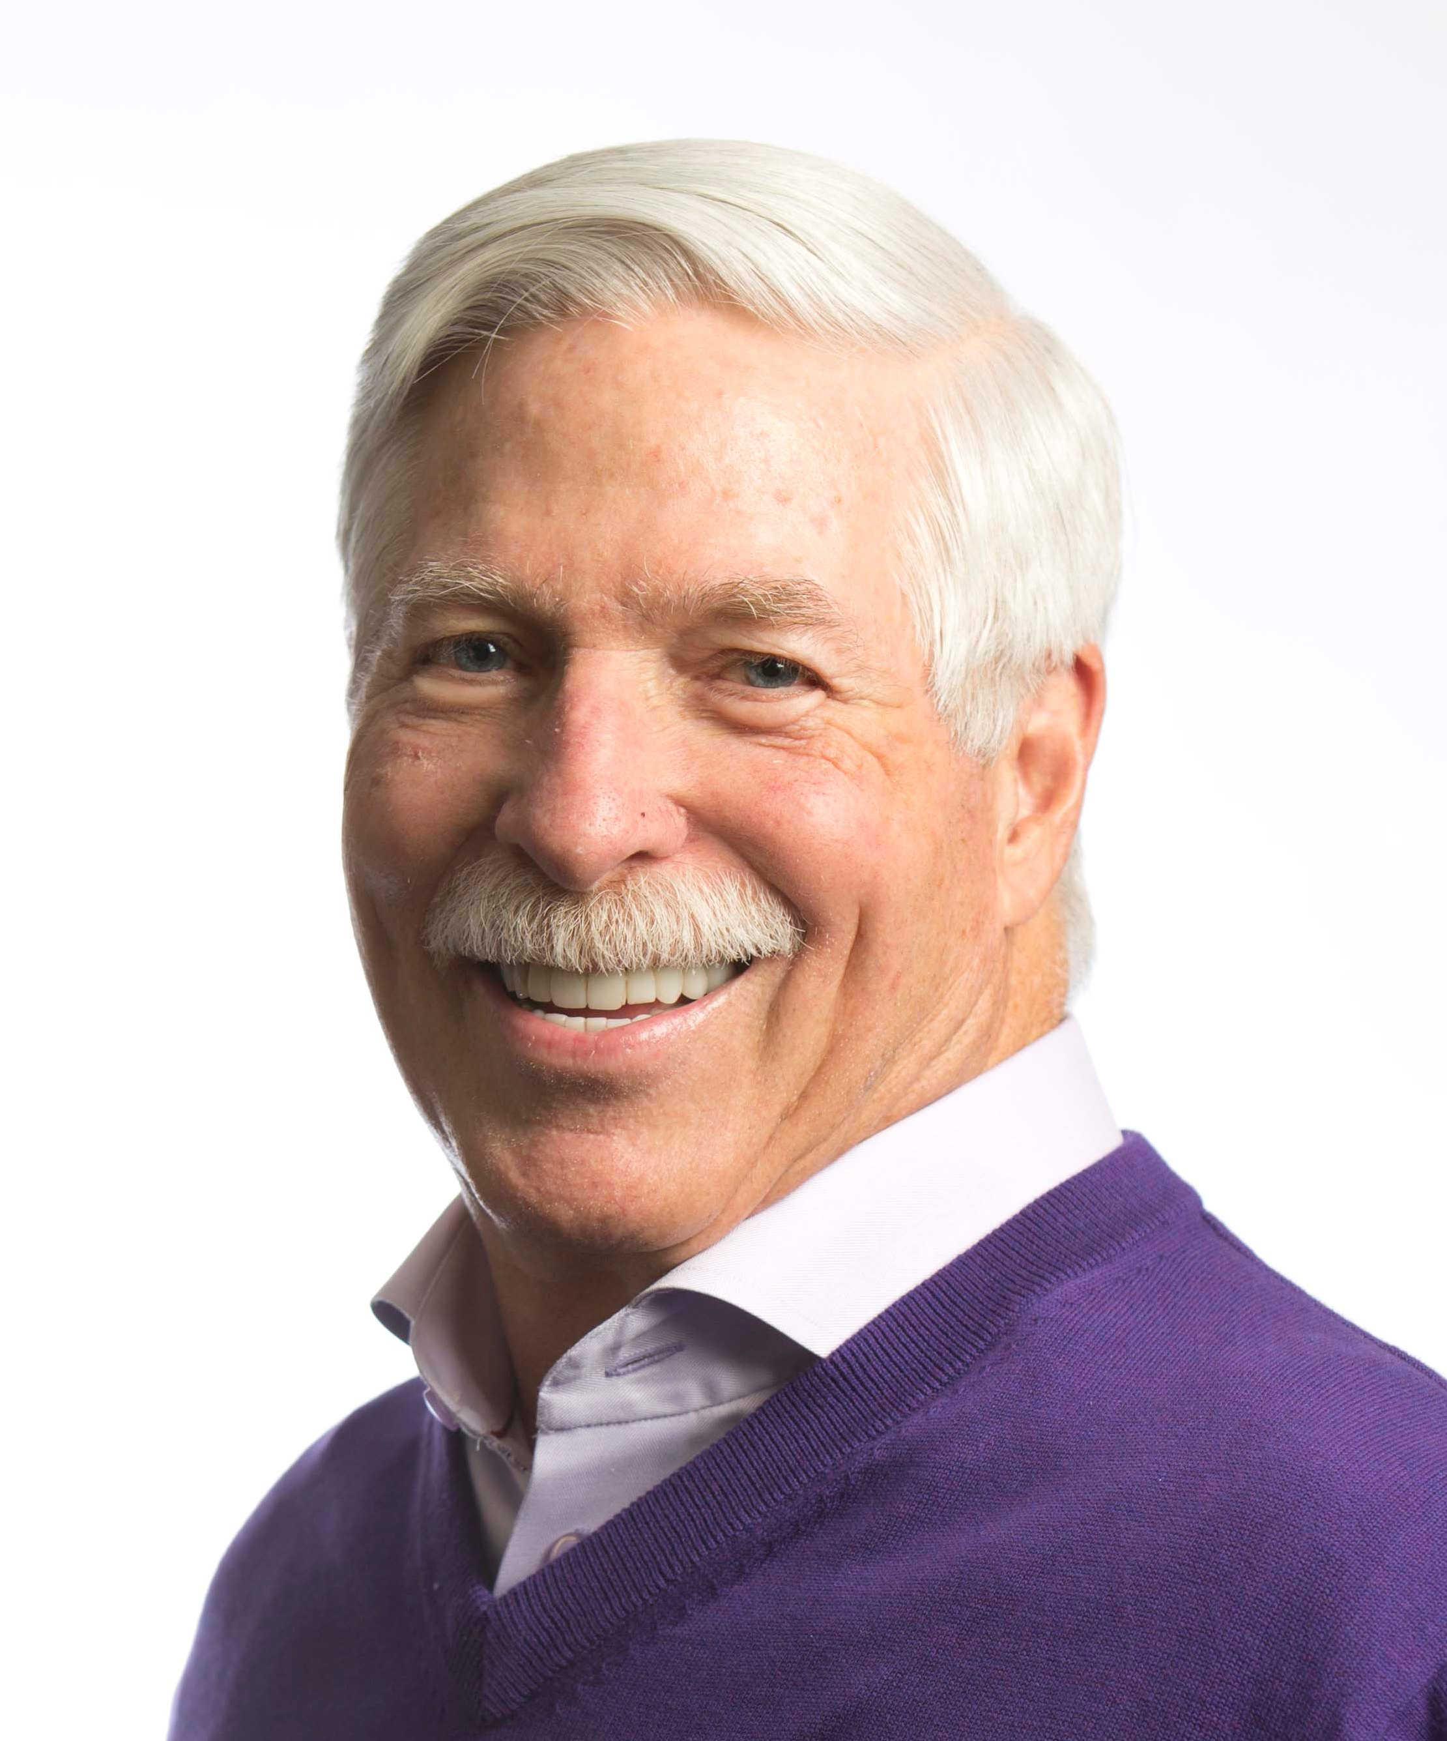

Airway Focused Orthodontics for Children
Today the emphasis is on Airway Focused Orthodontics for Children. Dr. Rondeau has been focused on the airway for over 35 years. He is offering a course for you and your team as a review of this treatment philosophy. 85% of the cases he will be presenting are new and they are simple cases that you see in your office on a daily basis. The key to any successful practice is to have a well-educated and motivated team.

Dr. Rondeau is one of North America’s most sought after clinician who lectures over 100 days per year. Over 23,000 dentists have attended his courses and study clubs worldwide. He has an extremely busy practice, which is limited to the treatment of patients with orthodontic, orthopedic, TMD, and snoring and sleep apnea problems. He has online courses on orthodontics, TMD and snoring and sleep apnea. Along with the over 35 published articles, he recently completed his book “Early Treatment Orthodontic for Children”.

