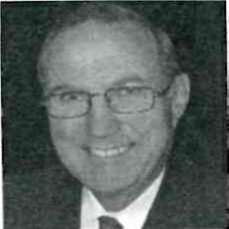
Dr. Terrance Spahl
The Three Kings of FJO Treatment
Codes: 113; Functional/Orthopedic
CE Hours: 4 Hours

Three basic appliance techniques lay at the heart of Anterior Repositioning Treatment (ART) for the Ortho/TMJ/Headache patient, The Functional Advancing Condylar Translation appliance (FACT), the Bionator “Retainer” and the “SSV”. At the conclusion of this lecture the attendee will: understand why the FACT appliance is the common sense “super-splint” for TMD patients of an advanced level of chronic headache joint pains, know why the Bionator H.S. Retainer is the perfect night time appliance for use in conjunction with the day time FACT, and have knowledge of the most advanced technology available in appliance design and usage for easily and rapidly closing post-ART posterior open bites- is the SSV. Its design, use and adjustment will be thoroughly explained.
Dr. T.J. Spahl is a graduate of the University of Minnesota in 1969. He is an IAO Certified Senior Instructor. He has lectured extensively throughout the United States and 8 foreign countries. He is the principle author of a trilogy of textbooks on orthodontics and TMJ therapeutics written in the 1980’s in conjunction with the late Dr. John Witzig.

